Playtesters: María Orantes, Mario Orantes, Lucas Lee.

The game works as an arguing game and discussion where the main goal is to promote their own product even if the sabotages made to one’s product make the potion seem funny or just not make sense. The play testers had a laugh even if a session was only 10 minutes long, but the game is intended to work as a silly experience where the wizards keep trying to make sense out of possible non-sense that occurs. A broken mechanic might have been that since all wizards could imbue effects to their potions from all their arcana, the potions can be too unfair at times, or just too many positive effects to make the sabotaging meaningful.

Intended Experience: The intended experience was to make an RPG where people will use their imagination in order to maximize the potential of their options while also making the other player’s options not as appealing while also using the thematic of the Tarot cards, to use as an element for the potions. With Wizard’s Potion, the experience I wanted to achieve was possible, but there are several balancing changes that the game might need in order to make it fully viable and fair for everybody else, as there are some combinations which can be more unbalanced than others.

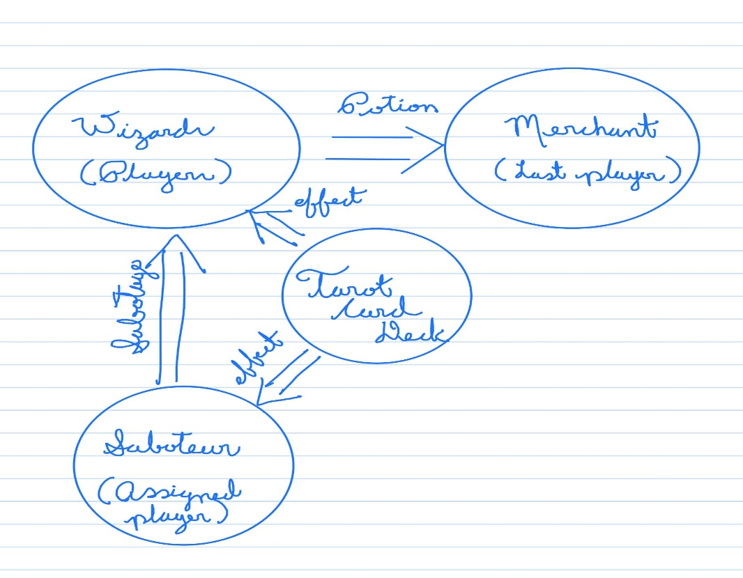

Changes:

In the early stages of the game, the wizards could include any effects that they wanted in the potions. Moreover, Some potions were outright unbeatable as there were only positive effects, so I included the sabotaging phase in order to balance the potions and to add more imagination into the gameplay in order to make a possible “unbeatable potion” greater weaknesses and add variability to the gameplay.